

EBAY CONTROLLER TEST DATA SHEET

P/N: N_A Date: 08/04/2018 Time: 17:12

S/N: N_A Tested by: vxd

Hardware Rev: BLDC_60A_V6 Approved by: vxd

Software Rev: N_A

Tester Software Version: 1.2i

Equipments Used

Equipments Model No Serial No

Power Supply

Digital Multimeter

CAN Interface

Resistance Decade Box

PC

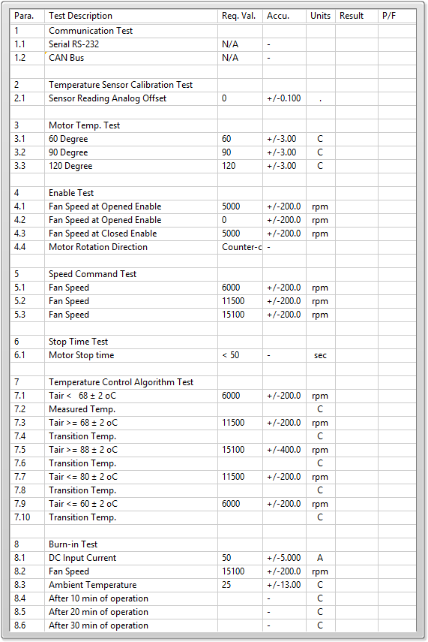

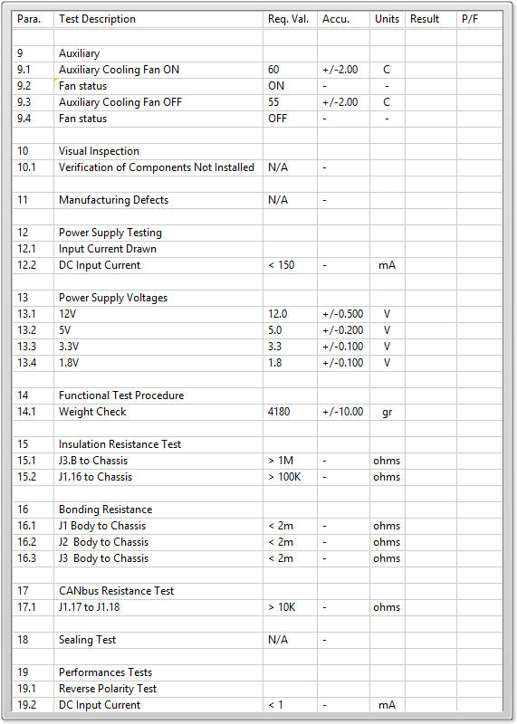

General result:

Test-Operator:____ vxd_________ Q.A.:__________________________